### Part 1

* Result of 255 * 255 = 65025

- Result of Timer 1 with a prescaler of 1 was 2833

- 0.0625 us * 2833 = 177.06 us or 0.17706 ms



Figure 3: Snippet of the outputs for Design 1

### Part 2

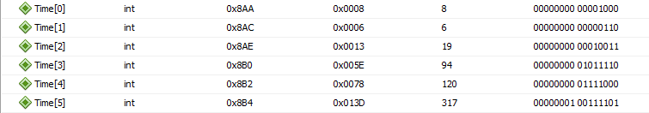

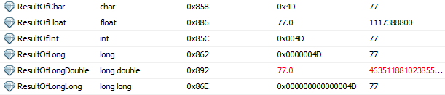

### Part 2 with division

Op1 = 85, Op2 = 14

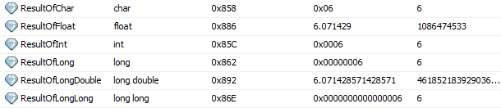

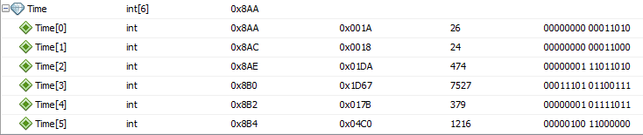

Part 3.

Q16.16 multiplication



* Time of execution = 28 us

Q15.16 Addition



* Time of execution = 2.18 us

Float addition



Time of execution = 8.25 us